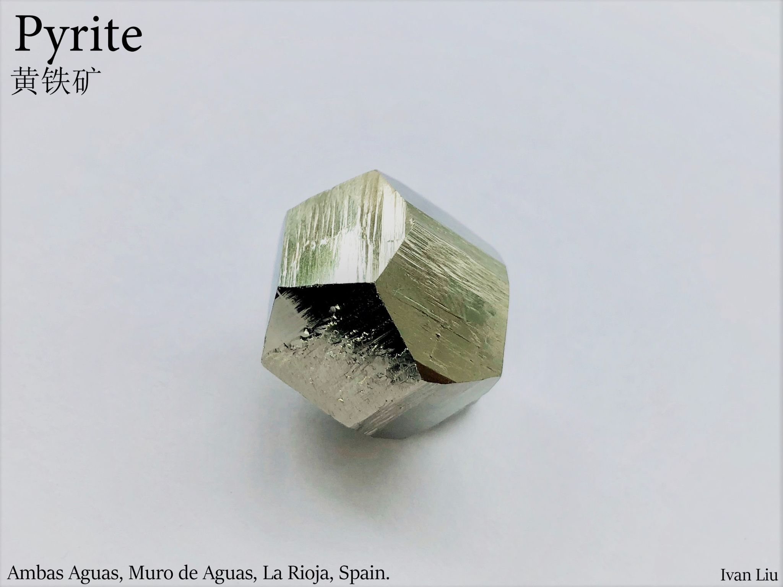

**Analytical Minerals Database System**

System Proposal

Jiangteng Liu | System Analysis | 12/04/2021

- **Proposal outlines**

Introduction

1. The main idea of this system

2. What information can the users obtain

3. What data will be stored, and how the system sort and used this information

4. Where the data will come from

5. The origin of this idea

6. The target user

7. Other comparable systems

8. Conceptual Diagram of system

- **Introduction**

This system proposal is an improvement based on previous minerals search databases. Most of the features contained in this system can be obtained from other minerals databases. But what is new is that, based on the information provided by the users, this database can help them to analyze and recognize different minerals. Because in the mineral communities, a good collector needs to recognize their minerals and the minerals’ localities.

**1.** **The main idea of this system**

There are two core features in this system. The database of minerals and the analytical search engine. The database contains all the detailed information for each mineral, including their picture, and their locality (Location where the specimen was mined). The system will sort out the mineral base on their properties, and locality. So, if a user obtained unknown specimens or known specimens with unknown localities then the analytical search engine can assist the users to identify the mineral’s types and localities by using the information provided by them.

**2.** **What information can the users obtain**

First of all, the most important information to the users is the details for minerals. For example, the chemical and physical properties as well as the crystal habits and crystal forms. The second important information users can access is the photos of specimens taken by other people.

**3.** **What data will be stored**

When the users search the name of a mineral, the information will present into 6 categories.

1. **Localities**

Type Locality

1. **Photos of the mineral**

Size of the specimen

Field of view

1. **Physical properties**

Lustre

Transparency

Colour

Streak

Hardness

Tenacity

Cleavage

Fracture

Density

Specific gravity

Radioactivity

Luminescent

Electromagnetism

1. **Optical datas**

Type

RI value

2V

Max Birefringence

Surface Relief

Dispersion

Pleochroism

Others

1. **Chemical properties**

Formula

Element’s list

Common Impurities

Solubility

Blowpipe tests

Acid reaction

1. **Crystallography**

Crystal system

Class

Cell Parameters

Ratio

Unit Cell V

Z

Morphology

Twinning

Crystal Structure

Crystal forms

X-Ray Powder Diffraction

The system will also classify the information above into three main categories to identify minerals. Invasive technique, non-invasive technique, and the locality of the mineral. Invasive techniques require to do damage to the specimens, non-invasive techniques will not damage the specimen.

After the users complete these three techniques with their specimens, the system will be trying to match these with the database. Then the system will present a list of minerals. These minerals will most likely be the minerals the users are trying to identify. Lastly, the user will check all the photos of the mineral in the list to identify the specimens.

**4. Where the data will come from**

Since most of the minerals either consist of chemical compounds(substances that are composite of two or more elements) or a single element, most of the time, the same mineral from different localities will have the same properties. So, a large percentage of the data for a mineral does not need to be recollected, especially in the chemical and physical properties. This portion of data can be transferred from Mindat.org, the largest online mineralogical database. However, the environment of the mineralisation process still affects some properties such as the size of the crystal and its crystal form. So, this part of the data will be uploaded by our users, including the photo of the minerals, and their locality.

**5. The origin of this idea**

This idea is coming from two origins. Firstly, as a mineral collector, I frequently use Mindat.org’s database to learn about minerals’ properties and crystal form. Also, I use it to identify the locality of a mineral. According to my personal experience, it indeed is the best mineral database, but it is quite poor at helping me to identify minerals’ locality. Even with known minerals, I still have to go through the photo one by one. With unknown minerals, I do not even know where to start from. At the beginning of this year, I bought a book called Minerals of the World. At the end of this book, I discover there are indexes on properties of minerals to help to identify them. For example, using physical properties such as color, hardness, and specific gravity as well as chemical properties like solubilities and blowpipe tests. But even though this index is very detailed, it still lacks data size and efficiency. So, this idea of combining an online database with identification techniques appears in my mind. Because the online database can be updated by the users, it will contain the newest information about the locality. A book can only contain at most 400 or 500 minerals, so using an online database increases the sample size as well.

**6. The target users**

The target users can be separated into three groups, amateur collectors, more experienced collectors, and people who need data for certain minerals. The mineral database will target all three groups, where they can understand the information of the minerals. The analytical search engine is more often used by mineral collectors. Where amateurs may use it to identify the mineral and the more experienced collectors will use it to identify the locality of the minerals.

**7. Other comparable systems**

There are indeed lots of mineral databases providing minerals’ information, for example, Mindat.org. But yet I have not seen any of them have an online analytical search system. Most of the identification techniques are provided through books. I think the reason why there hasn’t been anything like this is that creating such a system requires lots of time and testing. Especially with the localities and photos, since there are 260000 localities and nearly 650000 photos just on Mindat.org alone, sorting these data in a short time is very difficult.

**8. Conceptual Diagram of system**

